PostgreSQL Architecture
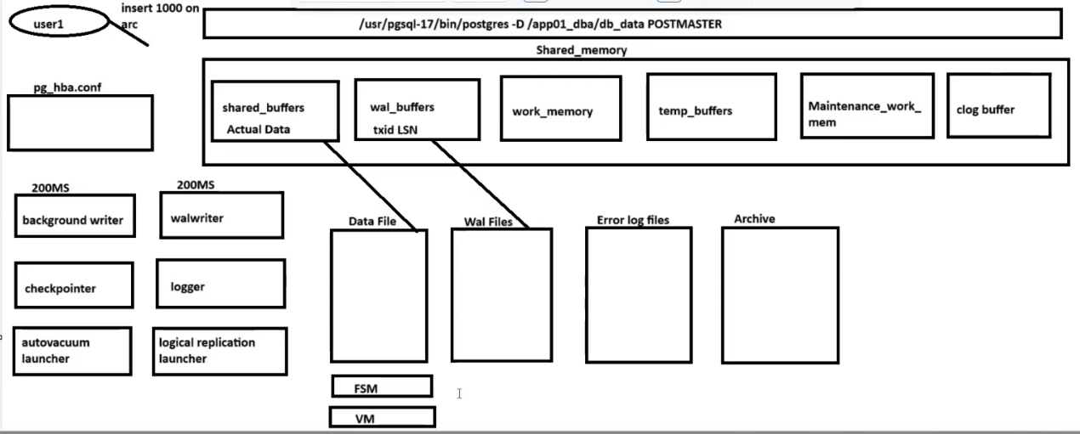
dba@example ~]$ ps -ef|grep postgres
dba 3956 2245 0 07:09 ? 00:00:00 /usr/pgsql-17/bin/postgres -D /app01_dba/db_data
dba 3957 3956 0 07:09 ? 00:00:00 postgres: logger
dba 3958 3956 0 07:09 ? 00:00:00 postgres: checkpointer
dba 3959 3956 0 07:09 ? 00:00:00 postgres: background writer
dba 3961 3956 0 07:09 ? 00:00:00 postgres: walwriter
dba 3962 3956 0 07:09 ? 00:00:00 postgres: autovacuum launcher
dba 3963 3956 0 07:09 ? 00:00:00 postgres: logical replication launcher
dba 4055 3775 0 07:09 pts/0 00:00:00 grep --color=auto postgres
[dba@example ~]$ psql -p 5432 -U dba postgres
psql (17.4)
Type "help" for help.
postgres=# create table arc(id integer,name varchar(20));
CREATE TABLE
postgres=# \d+ arc
Table "public.arc"
Column | Type | Collation | Nullable | Default | Storage | Compression | Stats target | Description
--------+-----------------------+-----------+----------+---------+----------+-------------+--------------+-------------
id | integer | | | | plain | | |
name | character varying(20) | | | | extended | | |
Access method: heap
postgres=# select pg_relation_filepath('arc');
pg_relation_filepath
----------------------
base/5/32789
(1 row)
postgres=# \q
[dba@example ~]$ cd
.cache/ db_data/ db_wal/ postgresql/
[dba@example ~]$ cd db_data/base/5/
[dba@example 5]$ ls -lrth 32789
-rw-------. 1 dba dba 0 Mar 14 07:23 32789
[dba@example 5]$ ls -lrth 32789
-rw-------. 1 dba dba 440K Mar 14 07:31 32789
[dba@example 5]$ psql -p 5432 -U dba postgres
psql (17.4)
[dba@example ~]$ psql -p 5432 -U dba postgres
psql (17.4)
Type "help" for help.
postgres=# \dt
List of relations
Schema | Name | Type | Owner
--------+--------+-------+-------
public | arc | table | dba
public | orders | table | dba
public | tab1 | table | dba
public | tb1 | table | dba
public | test1 | table | dba
(5 rows)
postgres=# begin;
BEGIN
postgres=*# insert into arc values(generate_series(1,10000),'manu');
INSERT 0 10000
postgres=*# rollback;
ROLLBACK
postgres=#
[dba@example 5]$ cd ..
[dba@example base]$ cd ..
[dba@example db_data]$ vi postgresql.conf
[dba@example db_data]$ cd base
[dba@example base]$ cd 5
[dba@example 5]$ ls -lrth 32789*
-rw-------. 1 dba dba 24K Mar 14 07:31 32789_fsm
-rw-------. 1 dba dba 440K Mar 14 07:34 32789
[dba@example 5]$ psql -p 5432 -U dba postgres
psql (17.4)
Type "help" for help.
postgres=# select * from pg_class where relname='arc';
postgres=# \q
[dba@example 5]$ ls -lrth 32789*
-rw-------. 1 dba dba 0 Mar 14 07:58 32789_vm
-rw-------. 1 dba dba 16K Mar 14 07:58 32789_fsm
-rw-------. 1 dba dba 0 Mar 14 07:58 32789
[dba@example 5]$ psql -p 5432 -U dba postgres
psql (17.4)
Type "help" for help.
postgres=# select * from pg_stat_user_tables where relname='arc';
postgres=# \x
Expanded display is on.
postgres=# select * from pg_stat_user_tables where relname='arc';
postgres=# vacuum arc;
VACUUM
postgres=# select * from pg_stat_user_tables where relname='arc';
postgres=# \q
Basic structure of a table on disk
If you have a table called students, inside the database’s folder (like base/16384/), you’ll see something like this:
16384/12345 ← main data file (actual rows)
16384/12345_fsm ← free space map
16384/12345_vm ← visibility map

🧩 1. fsm — Free Space Map
Purpose: Tracks how much free space is available in each page (8KB block) of the table.
📖 Why it exists:
When PostgreSQL inserts a new row, it needs to know where there’s room.
Instead of scanning the whole table file, it looks at the fsm to quickly find pages that have enough space.
Example:Let’s say your table’s data file (12345) has 4 pages:
Page 1 → 2000 bytes free
Page 2 → 1000 bytes free
Page 3 → 0 bytes free
Page 4 → 4000 bytes free
The FSM will store a small summary:
[Page 1: 25% free]
[Page 2: 12% free]
[Page 3: 0% free]
[Page 4: 50% free]
So when PostgreSQL needs to insert a row of 1500 bytes,
it checks FSM → finds Page 4 → inserts row there directly.
No need to scan every page!
📦 Key point:
- FSM = a map of empty spaces in data pages.
- Used by INSERT and UPDATE to reuse space efficiently.
- Helps reduce table bloat.
🪞 2. vm — Visibility Map
Purpose:Tracks which pages contain only visible (fully committed) tuples.
If all tuples on a page are visible to everyone, PostgreSQL marks it in the VM.
📖 Why it exists:
The visibility map helps PostgreSQL skip pages during VACUUM and ANALYZE.
If a page is fully visible (no dead rows), there’s no need to scan it again.
Example:Imagine this:
Page 1 → All tuples committed → visible
Page 2 → Has some deleted rows → not visible
Page 3 → All tuples committed → visible
The VM will mark:
[Page 1: visible]
[Page 2: not visible]
[Page 3: visible]
When VACUUM runs, it will skip Page 1 and 3, saving tons of time.
It only scans pages that might need cleanup.
📦 Key point:
- VM = map of which pages are safe to skip during vacuum.
- Used by VACUUM and index-only scans.
- Greatly improves performance for large tables.
⚡ Quick summary
File | Name | Main purpose | Used by
tablename_fsm | Free Space Map | Find where to insert new rows (tracks empty space) | INSERT / UPDATE
tablename_vm | Visibility Map | Skip pages that don’t need vacuuming or scanning | VACUUM / ANALYZE / Index-only scans

